Felix Daily

Zong-Guo Xia

May 20th, 2022

Neighborhood Ranking for a Young Couple

First of all, let us define the scope of our neighborhood ranking-

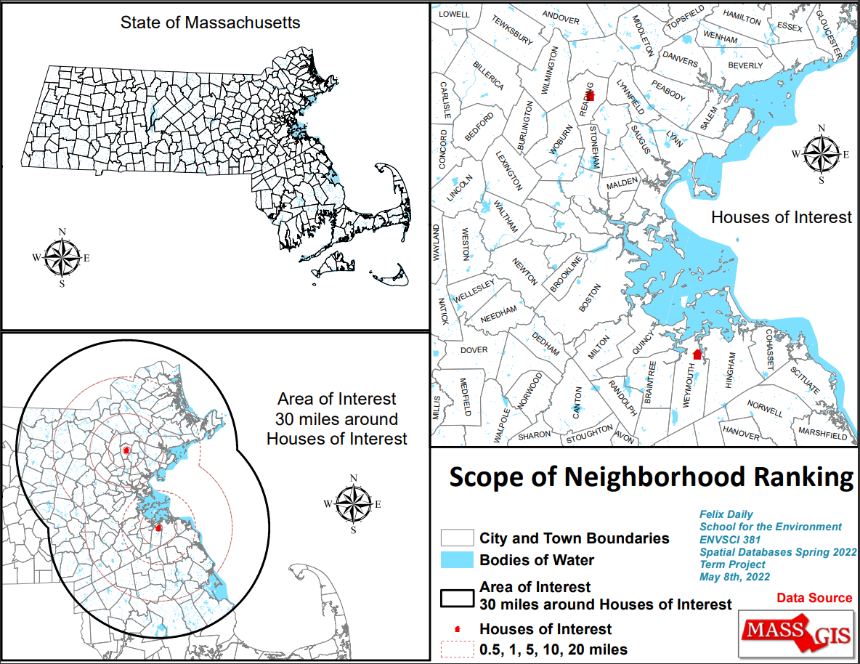 Let’s confine our search to the state of Massachusetts. Further, we want to be within driving distance of my mother and my fiance’s sister. These shall be referred to throughout as the ‘Houses of Interest’ and the combined 30 mile radius around their homes as the ‘Area of Interest’.

These data point were extracted using the exact addressed from the Mass address points Data file. Note that the Area of Interest extends beyond the Massachusetts state boundary. For now, we will only consider neighborhoods within the state. We have also chosen not to pursue living on a house boat, so any area in the water has been ruled out.

On to Relevant Spatial Variables-

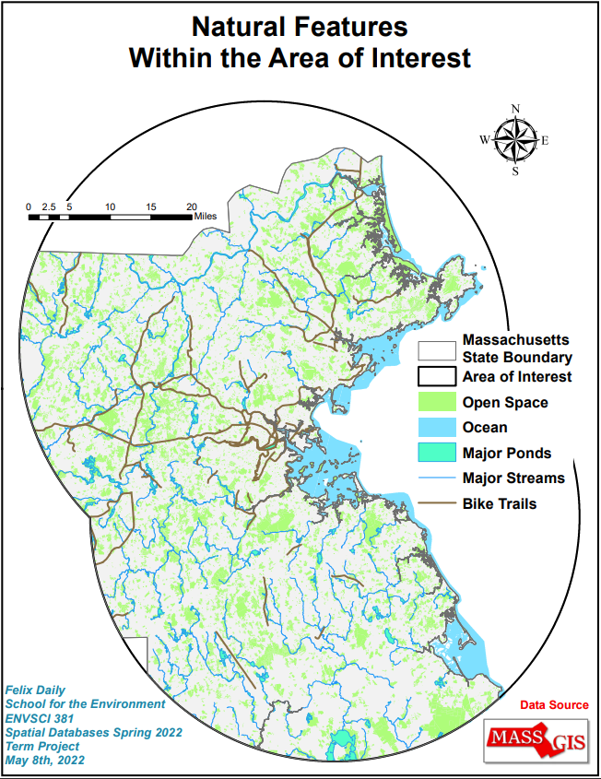

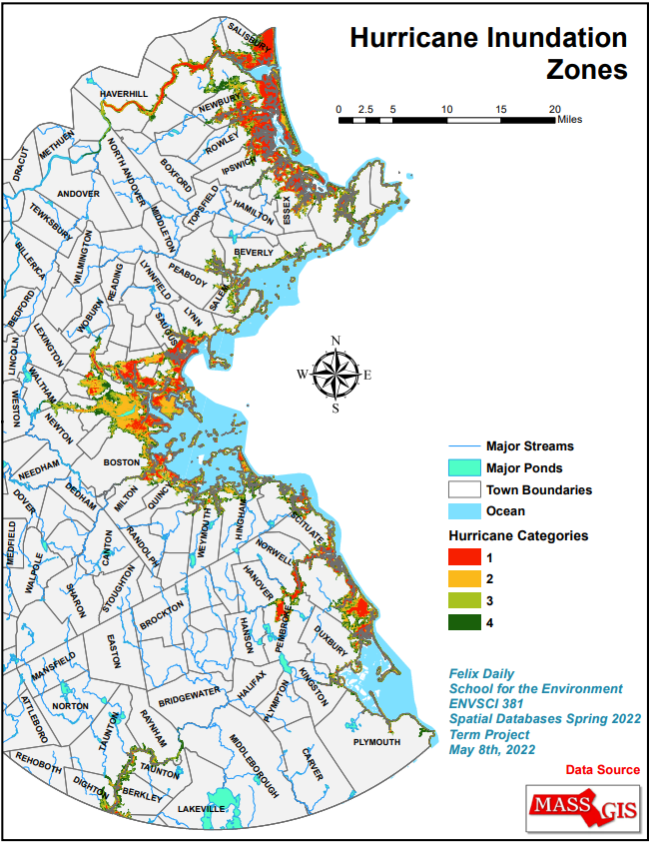Note that the category 4 Hurricane Inundation layer overlaps fully with the NOAA projected 10 foot sea level rise, and so only the Hurricane Inundation data was used. These areas have been given a weighty negative score and so you will see later in the heat map that they are all in the ‘zero’ rank.

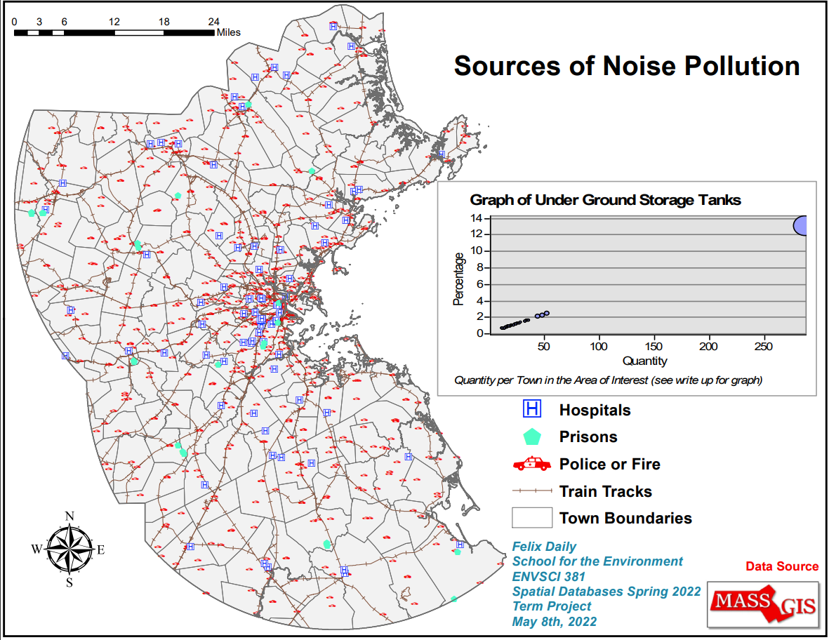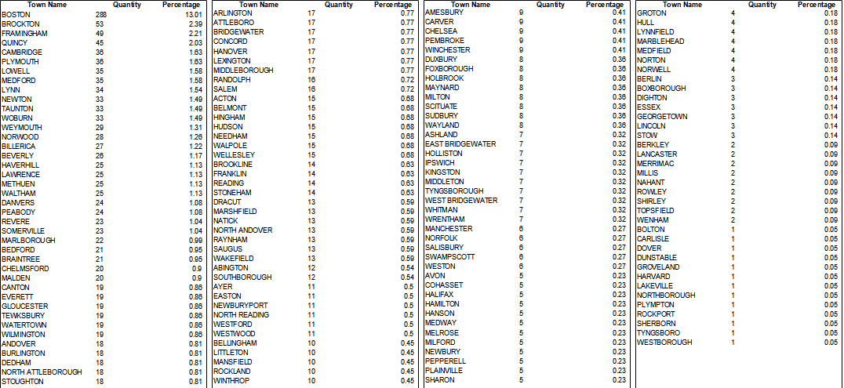Each town was given a bell-curve rank for their quantity of Underground Storage Tanks (See graph above)

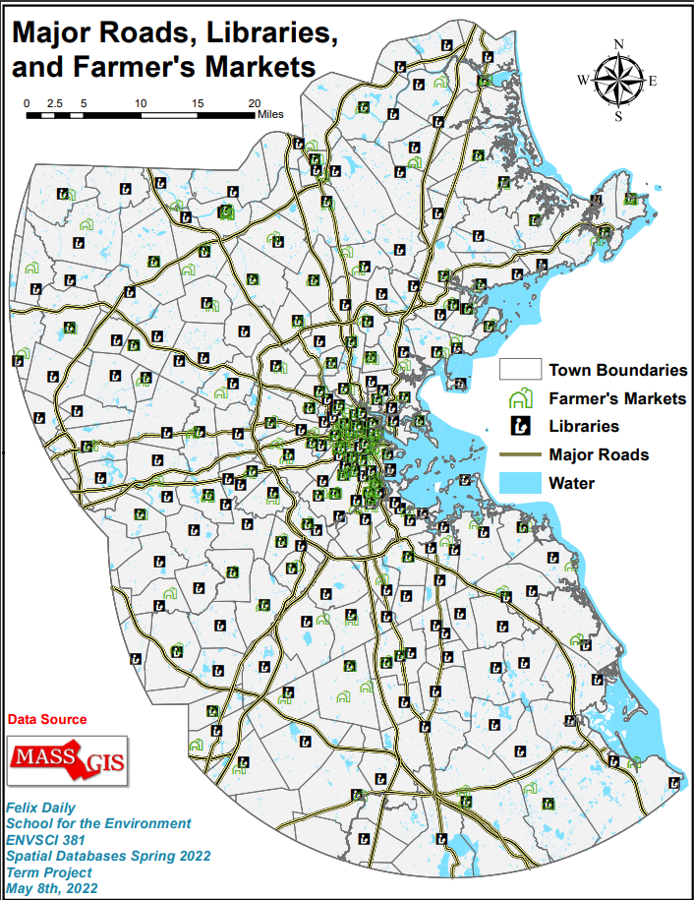

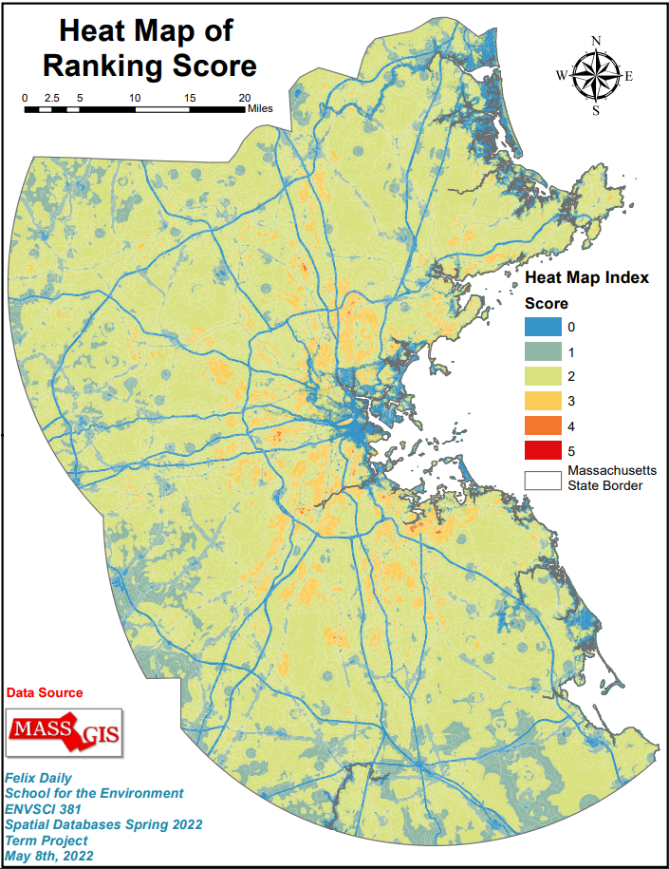Note that major roads are all ‘zero’ rank, as people cannot build houses *on* the highway.

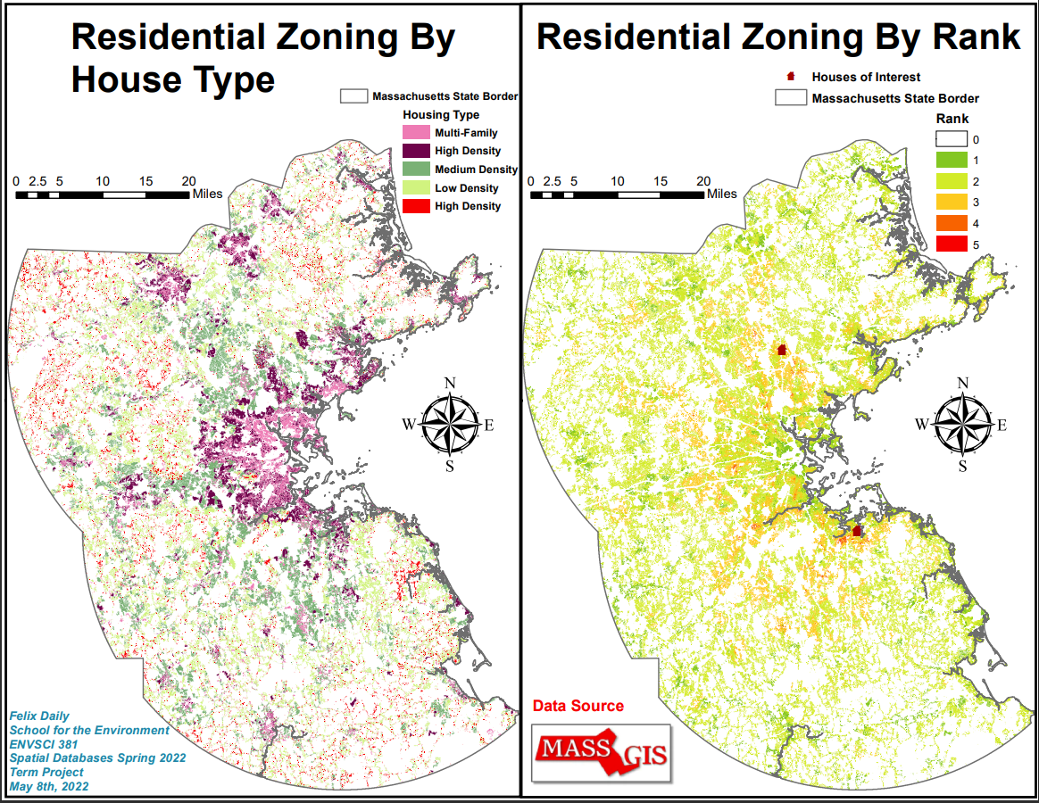

\*There is a typo in the left map, the Red ‘High Density’ should read ‘Very Low Density’

Here’s where the data starts to become meaningful- On the left we have areas with residential zoning, broken down by type (Multi-Family, High Density, Medium Density, Low Density, and Very Low Density). On the left, we have the intersect of the above heat map and the residential zoning. From lived experience I have given scores from -5 through 12 to the five residential zoning types, -5 for High Density, 5 for Multi-family, 8 for Very Low Density, 10 for Medium Density, and 12 for Low Density.

I took time to cross reference places I had lived previously to arrive at these scores. We are not misanthropes, but a little elbow room is nice.

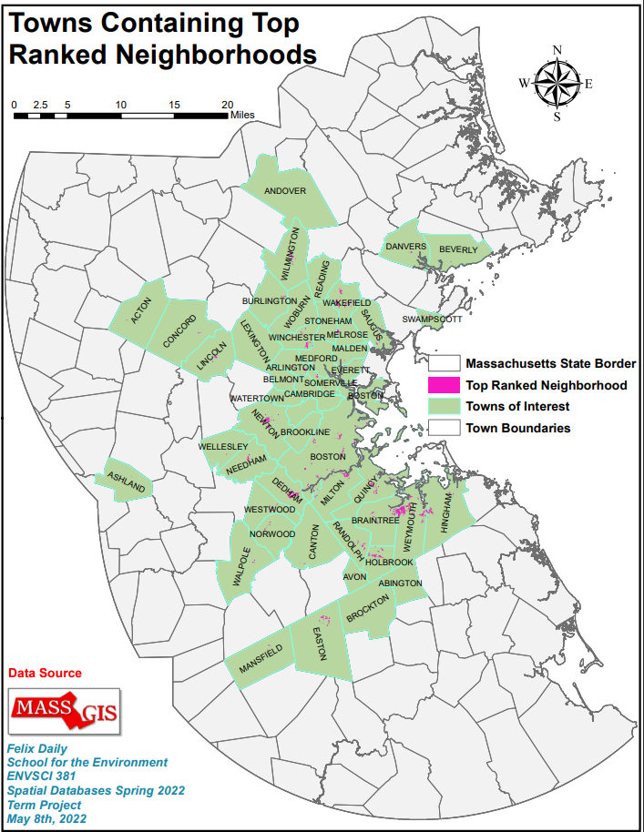 Finally we have the top ranked neighborhoods and the town they are in. Further application would be picking a selection of these top choices and comparing them to reality and the housing market. Then, I expect, back to the drawing board.

Thank you for a wonderful semester!! All the best! I hope you have a relaxing summer!